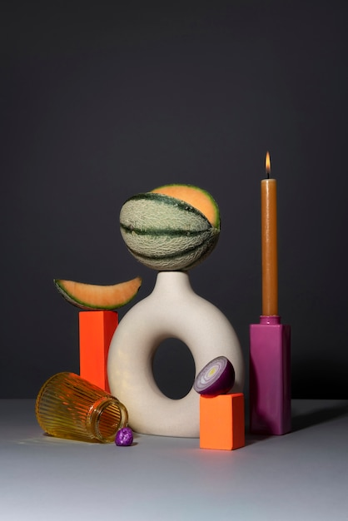

This image offers several unique shapes that are challenging yet seemingly achievable. Starting from left to right, there is a tapered cylinder on its side. This object would challenge my ability to orient an object with a side not at 90 degrees of its base and having it lay flat on a plane. Next to the top of a box there is a slice of melon that could be made from two prisms connected and altered to achieve the unique shape. In the middle there is a vase with the remaining melon on top. This vase would serve as the multiple shaped object. Using a torus as the bulk of the body I could add a cylinder to the top to make the mouth of the vase. The melon would just be a sphere with dual prisms taken from it. From here I would use a half sphere to make the onion and an elongated cylinder for the candle stick.

There will be omissions and potential omissions from this image. The only object to be intentionally excluded is the purple rock. The object is unique and would require a more detailed plan than I am able to give at this time. A potential object omission would be the melon slice. I am aware that I may be unable to round the bottom of the dual prism, if that ends up being the case then I will omit the slice in favor of a whole melon. Rest assured that I will still attempt the slice.

These objects will challenge my scaling, orientation, and overall creation. I expect the slice and the vase to give me the greatest challenge. Several objects are staged on boxes, these boxes will remain as it will add practice and a challenge to achieve different heights of objects.

Citation for the image:

*Geometric Still Life Images - Free Download on Freepik*, www.freepik.com/free-photos-vectors/geometric-still-life. Accessed 7 Nov. 2024.